MLHFM – Linearisierung der Heißfilmspannung

MLHFM = Linearization of MAF sensor output (voltage) / MAF Linearization Sensor Output - MAF Table
X / Y Dezimalzahl in Hexzahl (Decimal to hexadecimal number) [dez] (dec) /
Luftmassen-Durchsatzes (air mass flow rate), 16 Bit, mit Offset [kg/h]

Kg/h
Factor 0,125
Offset -200

g/sec
Factor 0,0277778
Offset -5,55556

The air mass sensor (HFM) is scanned every 1ms. The scanned voltage is first linearised
(MLHFM). The characteristic contains only positive values, for further calculation of the air mass flow. For this reason, when using a HFM5 an offset (MLOFS) for the reverse flow range must be taken into account when calculating the values for MLHFM.

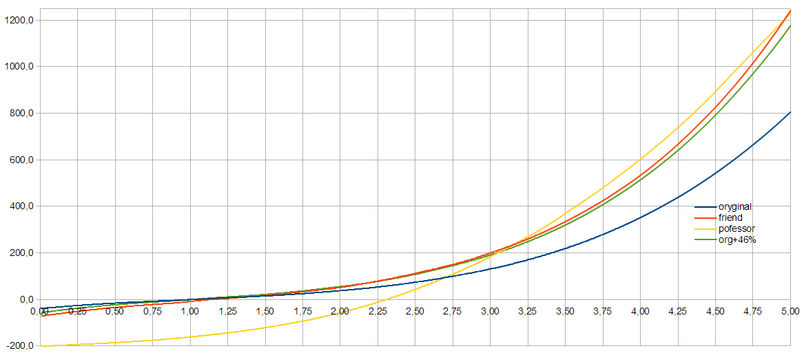

The calculated air mass values are then added together via a segment in a memory. Once per segment, at the beginning of the charge calculation, the totaled value is arithmetically averaged via the preceding segment, i.e. it is divided by the number of scans of the last segment and then the characteristic offset MLOFS is deducted.

The value is then multiplied by a pulsation correction value taken from the map KFPU. This air mass flow is delivered to the output as a 16-bit value mshfm w and as an 8-bit value mshfm.

MLHFM is for a particular sensor, and KFKHFM is to correct the MAF reading for the intake tract.
I believe that MLHFM should be portable between tunes as long as the MAF is scaled correctly and not under scaled.
KFKHFM would be much less portable because it is directly tuned for a particular intake tract.

MLHFM is the table for converting MAF voltage in volts into air mass in grams/second. It should be a 1x512 ME7xx map in the B5 S4. If you increase the size of your MAF housing you will need to scale this map up, and if you decrease the size of your MAF housing you will need to scale this value down.
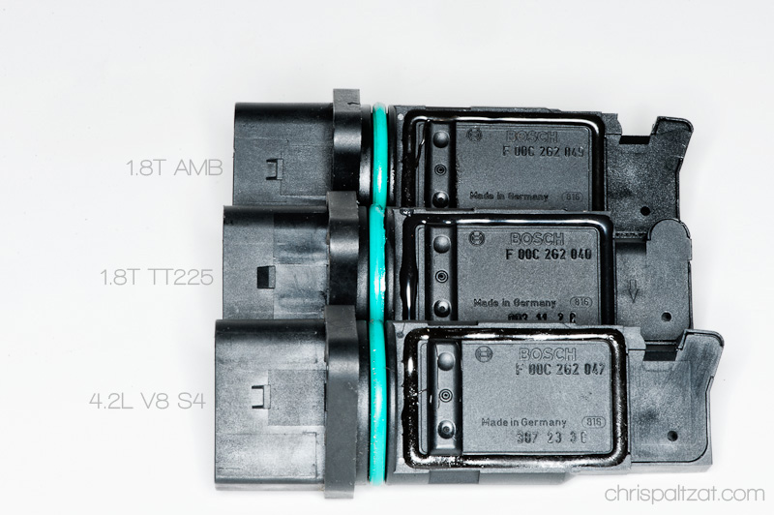

MLHFM is 0.1 for kg/h or 0.0277778 for g/sec offset 200kg/h (5,55556 g/sec)

1 kg/h = 0.2777777777778 gr/sec
The uhfm_w axis doesn't really exist. It's a hex offset from the base. You can visualize it as 512 (ME7xx) or 256 (M38x/M592) points starting at 0.00 - 4.99.

For ME7xx the factor for uhfm_w is 0.00488281(8bit) so half that (16 bit) and you have 0.009766. Multiplying the row number by 0.009766 will give you an axis value.

For M38x/M592 the factor for uhfm_w is 0,009765625 (8bit) so half that (16 bit) and you have 0,01953125. Multiplying the row number by 0.009766 will give you an axis value.

